

KENNEDY ROAD, NEAR R.T.O., PUNE 411001

Institute Code: 0141

# A MICRO-PROJECT REPORT

**ON**

**PROGRAM TO EVALUATE PREFIX EXPRESSION**

Academic Year: 2023-24 Program Code: CO3I

Course: DSU Course Code: 22317

**Submitted By:**

|  |  |  |  |  |
| --- | --- | --- | --- | --- |
| **Roll No** | **Student Name** | **Branch** | **Batch** | **Enrollment No.** |
| 1525 | **Shubham Giri** | SYCO | CO2I | 2201410262 |
| 1526 | **Rushi Gujarathi** | SYCO | CO2I | 2201410263 |
| 1527 | **Param Jadhav** | SYCO | CO2I | 2201410267 |

**Under Guidance of:**

Mrs. P. P. Bastawade



KENNEDY ROAD, NEAR R.T.O., PUNE 411001

Institute Code: 0141

## CERTIFICATE

Certified that this micro project report titled “**PROGRAM TO EVALUATE PREFIX EXPRESSION.”** is the bonafide work of Ms./Mr. **Shubham Giri ,Rushi Gujarathi, Param Jadhav** Roll. no. **1525, 1526, 1527** of second year diploma in Computer engineering for the course: **Data Structure using C** Course code: **22317** during the academic year 2023-2024, who carried out the micro project work under my supervision.

Name & signature of Subject teacher

Mrs. P. P. Bastawade

**COs addressed by the micro-project:-**

22317.(C) Perform Basic Operations on stack.

22317.(C) Implement basic operations on stack to evalution of Prefix Expression.

.**Major learning Outcomes achieved by students by doing the micro-project a) Practical Outcomes:-**

1] Stack operations push, pop, display.

2] Evaluation of prefix expression.

**b) Unit outcomes:-**

1. Explain prefix operations to be performed on data structures.
2. Develop algorithm to push and pop operation for given item in the stack.

**c) Affected Domain Outcomes:-**

1] Follow safe practices.

2] Practice energy conservation.



## COMPUTER ENGINEERING DEPARTMENT

**VISION AND MISSION OF THE INSTITUTE**

* **VISION:**

Achieve excellence in quality technical education by imparting knowledge, skills and abilities to build a better technocrat.

* **MISSION:**

**M1:** Empower the students by inculcating various technical and soft skills.

**M2:** Upgrade teaching-learning process and industry-institute interaction

**VISION AND MISSION OF THE COMPUTER DEPARTMENT**

**VISION:**

“ Enhance skills by providing value based technical education for fulfilling global needs in the field.

**MISSION:**

* To provide quality education in computer engineering by improving psychomotor skills.

* To develop positive attitude, communication skills, team spirit and entrepreneurship.

* To develop awareness about societal and ethical responsibility for professionalism.



## COMPUTER ENGINEERING DEPARTMENT

**PROGRAM OUTCOMES (POs)**

|  |  |
| --- | --- |
| **PO1** | **Basic and Discipline specific knowledge:** Apply knowledge of basic mathematics, science and engineering fundamentals and engineering specialization to solve the engineering problems. |
| **PO2** | **Problem analysis:** Identify and analyze well-defined engineering problems using codified standard methods. |
| **PO3** | **Design/ development of solutions:** Design solutions for well-defined technical problems and assist with the design of systems components or processes to meet specified needs. |
| **PO4** | **Engineering Tools, Experimentation and Testing:** Apply modern engineering tools and appropriate technique to conduct standard tests and measurements. |
| **PO5** | **Engineering practices for society, sustainability and environment:** Apply appropriate technology in context of society, sustainability, environment and ethical practices. |
| **PO6** | **Project Management:** Use engineering management principles individually, as a team member or a leader to manage projects and effectively communicate about well-defined engineering activities. |
| **PO7** | **Life-long learning:** Ability to analyze individual needs and engage in updating in the context of technological changes. |

**PROGRAM SPECIFIC OUTCOMES (PSO)**

The Diploma in Computer Engineering will prepare students to attain:

* **PSO 1:** Use state-of-the-art technologies for operation and application of computer software and hardware.
* **PSO 2:**Maintain computer engineering related software and hardware systems.

**INDEX**

|  |  |  |
| --- | --- | --- |
| **Sr. No.** | **Content** | **Page No.** |
| 1. | Annexure I | 6-8 |
| 2. | Micro Project Proposal | 6-8 |
| 3. | Annexure II | 9-13 |
| 4. | Rationale | 9 |
| 5. | Aims/Benefits of the Micro Project | 9 |
| 6. | Course Outcome achieved | 9 |
| 7. | Literature Review | 9 |
| 8. | Actual Methodology Followed | 10 |
| 9. | Actual Resources Used | 10 |
| 10. | Output of the Micro Projects | 10-12 |
| 11 | Skill Developed / Learning outcome of the Micro Project | 13 |
| 12. | Applications of the Micro Project | 13 |

### ANNEXURE I Micro Project Proposal

***“*PROGRAM TO EVALUATE PREFIX EXPRESSION.*”***

**1.0 Aims/Benefit of the Micro Project:**

1. It helps to develop programming skills.
2. It increases skill for developing programs using data structure concepts.
3. Enhances the techniques and creativity for using data structure.
4. It helps to develop logical thinking.
5. Help to develop creative thinking.
6. Concepts of data structure get cleared.
7. Evaluates planning and working abilities.

**2.0 Course Outcomes Addressed:**

1. Perform basic operations on stack.
2. Implement basic operations on stack for evaluation of prefix expression.

**3.0 Proposed Methodology:**

1. Select one topic for a micro project that you find very simple.
2. Consult with your teacher for finalization of the topic.
3. Make a draft copy of the micro project proposal.
4. Take approval from the teacher.
5. Make a list of resources required such as raw material, instruments, software. f. Execute Micro project.
6. Test Micro project.
7. Observe outputs/Results of Micro projects.
8. Prepare Micro Project Presentation.
9. Prepare Micro project report for submission

**4.0 Action Plan:**

|  |  |  |  |  |
| --- | --- | --- | --- | --- |
| **Sr. No.** | **Details of Activity** | **Planned Start Date** | **Planned Finish Date** | **Name of Responsible Team Members** |
| 1 | Formation of groups | 24-07-2023 | 24-07-2023 | All Members |
| 2 | Selected the topic for micro project | 24-07-2023 | 24-07-2023 | All Members |
| 3 | Discussed about the project | 01.08.2023 | 01.08.2023 | All Members |
| 4 | Assigned the work to each group member | 07.08.2023 | 07.08.2023 | Rushi Gujarathi |
| 5 | Detailed study of micro-project | 14.08.2023 | 14.08.2023 | All Members |
| 6 | Collected information on assignment topic | 21.08.2023 | 21.08.2023 | All Members |
| 7 | Started working on micro-project | 28.08.2023 | 28.08.2023 | All Members |
| 8 | Assembled all the data | 04.09.2023 | 04.09.2023 | Param Jadhav |
| 9 | Evaluation of data | 11.09.2023 | 11.09.2023 | Param Jadhav |
| 10 | Prepared rough copy of micro-project | 18.09.2023 | 18.09.2023 | Shubham Giri |
| 11 | Project proposal presentation to guide | 25.09.2023 | 25.09.2023 | All Members |
| 12 | Corrected the micro-project suggested by guide | 02.10.2023 | 02.10.2023 | Shubham Giri |
| 13 | Actual implementation of microproject | 9.10.2023 | 9.10.2023 | All Members |
| 14 | Execution of overall data / prepared final draft copy | 16.10.2023 | 16.10.2023 | Rushi Gujarathi |
| 15 | Final micro-project presentation | 23.10.2023 | 23.10.2023 | All Members |
| 16 | Micro-project submitted | `30.10.2023 | `30.10.2023 | All Members |

**5.0 Resources Required**

|  |  |  |  |
| --- | --- | --- | --- |
| **Sr. No.** | **Name of Resource/material** | **Specifications** | **Remarks** |
| 1 | Computer system | Any desktop or laptop computer with basic configuration | Used to prepare presentations, reports. |
| 2 | Office software package | MS office, Turbo C++ version  3.0, Dev C++ | For programming. |
| 3 | Printer | inkjet or laser printer | To print the copies. |

**Name of Team Members with Roll No’s:**

|  |  |  |  |
| --- | --- | --- | --- |
| **Sr. No.** | **Name of the Student** | **Task Performed** | **Roll No.** |
| 1. | Shubham Giri | Gathered the Data | 1525 |
| 2. | Rushi Gujarathi | Compiled code | 1526 |
| 3. | Param Jadhav | Created Draft Copy | 1527 |

Mrs. P. P. Bastawade

(Name & Signature of faculty)

**ANNEXURE - II**

### Micro Project Report

### *“*PROGRAM TO EVALUATE PREFIX EXPRESSION.”*”*

1. **Rationale:** The intention behind the project was to use all possible data structures to create a research based non-published application. In the prefix notation , first reverse the given infix expression .Then read the expression from left to right. Each encountered elements is examined.

If the element is an operator , then the two operands are popped from the stack and the desired

Operation is done.The result of the operations pushed onto the stack.This process is repeated till the end of the expression is encountered. The final result is popped on the stack.

**2.0 Aims/Benefits of the Micro Project:**

1. It helps to develop programming skills.
2. It increases skill for developing programs using data structure concepts.
3. Enhances the techniques and creativity for using data structure.
4. It helps to develop logical thinking.
5. Help to develop creative thinking.
6. Concepts of data structure get cleared.
7. Evaluates planning and working abilities.

**3.0 Course Outcomes Achieved:**

1. Perform basic operations on stack.
2. Implement basic operations on stack pop and push for evaluation of prefix expression.

**4.0 Literature Review:**

1. Information about Evaluation of prefix expression was taken from: prefix expression javatpoint.com
2. Some of information about Tower of Hanoi using recursion was taken from DATA SRUCTURE USING C BOOK
3. The logic of program was taken from tutorialpoint.com.
4. Program was compiled and run using TURBO C

This genealogy-based project is created for the first time and thus no comparisons are available for it. That’s the solo purpose of why the links direct to them. Other considerable thing is the usefulness once connected to database.

If its connected then high-level researchers can keep a track easily making their research process much simpler.

**5.0 Actual Methodology Followed:**

1. Searching information using various internet resources.
2. Verifying and proofreading the information.
3. Coding the program.
4. Checking the validity of the information.
5. Preparing a word document for the information to be typed.
6. Typing the information with appropriate font and font size.
7. Snapping suitable images for better clarification and pasting them in word document.

**6.0 Actual resources required:**

|  |  |  |  |
| --- | --- | --- | --- |
| **Sr. No.** | **Name of Resource/material** | **Specifications** | **Remarks** |
| 1 | Computer system | Any desktop or laptop computer with basic configuration | Used tp prepare presentations, reports. |
| 2 | Office software package | MS office, Turbo C++ version 3.0, Dev C++ | For programming. |
| 3 | Printer | Inkjet or laser printer | To print the copies. |

**7.0 Outputs of the Micro project:**

**Program Code:**

#include<stdio.h>

#include<conio.h>

#include<string.h>

#include<ctype.h>

int stack[20];

int top=-1;

void push (int x)

{

stack[++top]=x;

}

int pop()

{

return stack[top--];

}

int main()

{

char exp[20],revexp[20];

clrscr();

char *temp=NULL;

int n1,n2,n3,num;

printf("Enter prefix expression without space:");

scanf("%s",exp);

strcpy(revexp,strrev(exp));

temp=revexp;

while(*temp!='\0')

{

if(isdigit(*temp))

{

num=*temp-48; // convert exp.string to integer

push(num);

}

else

{

n1=pop();

n2=pop();

switch(*temp)

{

case'+':

{

n3=n2+n1;

break;

}

case'-':

{

n3=n2-n1;

break;

}

case'*':

{

n3=n2*n1;

break;

}

case '/':

{

n3=n2/n1;

break;

}

}

push(n3);

}

temp++;

}

printf("\n The result of prefix expression %s=%d\n\n",exp,pop());

getch();

return 0;

}

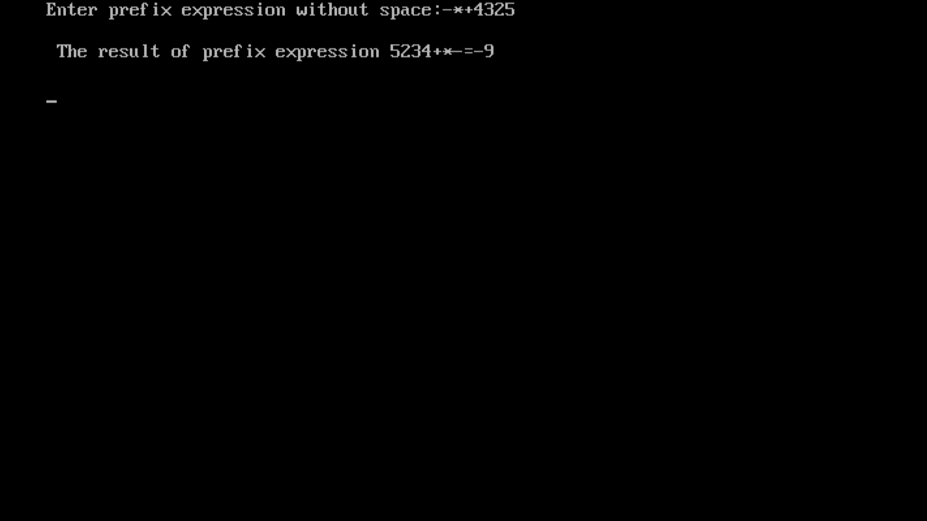 **Output:**

**8.0 Skill developed / Learning outcome of the Micro-Project:**

1. Communication skills.
2. Time management.
3. Working in a team.
4. Following ethics.
5. Stress management.
6. Psychomotor skills such as making documents and demonstrating them.
7. Presentation skills.
8. Leadership skills.
9. Problem solving.
10. Organization.

**9.0 Applications of the Micro-Project:**

1. Will help as a storage-research based application if connected with suitable IDE and database.
2. Help students to develop program using different logics.
3. It develops the assessment of problem solving.
4. Multiple stacks implementation example.
5. Track information systematically as the least important information will be stored at the bottom of stack.

Mrs. P. P. Bastawade

(Name & Signature of faculty)